
保良局方王錦全幼稚園
2022-2023年度
有關2023-2024年度上學期高班書簿雜費之事宜
敬啟者：
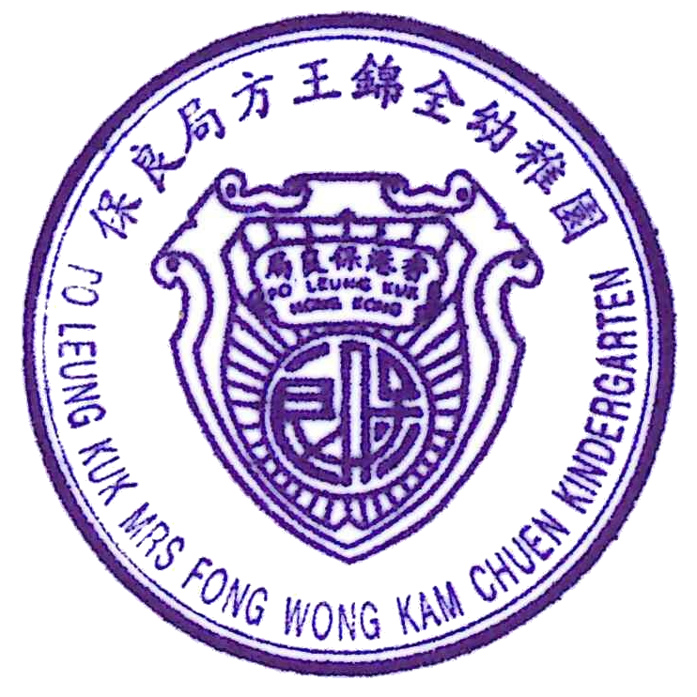
本園2023/2024年度上學期之學習參考資料、簿冊文具、圖工材料、茶點及其他用品各項如下，家長可自由選購或委託本園辦理，倘 貴家長委託本園代辦者，請於2023年6月9日或以前簽覆回條原張交回，本園將於2023年6月30日以銀行自動轉賬方式收取代辦費用，家長亦可以支票或現金方式繳交有關之款項。

保良局方王錦全幼稚園
2023年6月2日
類別 | 名 稱 |  |  | 出 版 社 | 冊 次 | 高 班 |  |  |  | 需要購買 | 不需要購買
 |  |  |  |  |  | 名稱 |  | 數量 | 售 價 | 請於適當空格內加✓
Ａ 學習參考資料 | 樂在培生學習系列 |  |  | 聯合培進教育出版社 | 上學期 | 《五顏六色》 |  | 1 | 60.80
 |  |  |  |  |  | 《健康100分》 |  | 1 | 60.80
 |  |  |  |  |  | 《學會愛地球》 |  | 1 | 60.80
Ａ 學習參考資料 | 來說普通話(2008第三版) |  |  | 教育出版社 | 上冊 | 《來說普通話 高上》 |  | 1 | 67.20
Ａ 學習參考資料 | Wonder Tales |  |  | 教育出版社 |  | Animal Colours |  | 1 | 56.10
Ａ 學習參考資料 |  |  |  | 教育出版社 |  | Wow, It is Banana Poop! |  | 1 | 56.10
Ａ 學習參考資料 |  |  |  | 教育出版社 |  | Watch That Plant Grow! |  | 1 | 56.10
Ａ 學習參考資料 |  |  |  | 教育出版社 |  | Rosie the Raindrop |  | 1 | 56.10
Ａ 學習參考資料 | New Phonics For Kids |  |  | 培生教育出版社 | 5 | New Phonics For Kids |  | 1 | 74.40
Ａ 學習參考資料 | 活動遊戲冊 |  |  | 聯合培進教育出版社 | 上學期 | 《活動遊戲冊(高班上學期)》 |  | 1 | 70.40
Ａ 學習參考資料 | 假期樂活動冊 |  |  | 聯合培進教育  出版社 |  | 《小鹿丁丁開派對》 |  | 1 | 28.00
Ａ 學習參考資料 |  |  |  | 聯合培進教育  出版社 |  | 《小貓吉吉去拜年》 |  | 1 | 28.00
Ａ 學習參考資料 |  |  |  |  | 小 計 |  |  |  | 674.80
Ｂ 圖工材料 | 紙類 |  |  | 美勞用紙 | B.1 |  |  |  | 50.70
Ｂ 圖工材料 | 顏色 |  |  | 圖工顏色類 | B.2 |  |  |  | 50.70
Ｂ 圖工材料 | 用品 |  |  | 美勞用品類 | B.3 |  |  |  | 50.70
Ｂ 圖工材料 | 其他 |  |  | 特別圖工材料 | B.4 |  |  |  | 89.40
Ｂ 圖工材料 |  |  |  |  | 小 計 |  |  |  | 241.50
Ｃ 簿冊及文具 | 項 目 |  |  |  |  | 名稱 | 數量
Ｃ 簿冊及文具 | 空白簿 |  |  |  | C.9 | 週記簿 | 1 |  | 2.80
Ｃ 簿冊及文具 | 設計活動補充資料 |  |  |  | C.12 | 兒歌書 | 1 |  | 19.00
Ｃ 簿冊及文具 |  |  |  |  | C.12 | Rhymes | 1 |  | 16.70
Ｃ 簿冊及文具 |  |  |  |  | C.12 | Oral | 1 |  | 16.70
Ｃ 簿冊及文具 |  |  |  |  | C.12 | 專題研習 | 1 |  | 15.20
Ｃ 簿冊及文具 |  |  |  |  | C.12 | 綜合遊戲冊 | 1 |  | 24.20
Ｃ 簿冊及文具 |  |  |  |  | C.12 | 語文遊戲冊(一) | 1 |  | 26.80
Ｃ 簿冊及文具 |  |  |  |  | C.12 | 語文遊戲冊(二) | 1 |  | 26.80
Ｃ 簿冊及文具 |  |  |  |  | C.12 | English Activity Book (1) | 1 |  | 22.70
Ｃ 簿冊及文具 |  |  |  |  | C.12 | English Activity Book (2) | 1 |  | 22.70
Ｃ 簿冊及文具 |  |  |  |  | C.12 | 識數遊戲冊(一) | 1 |  | 22.20
Ｃ 簿冊及文具 |  |  |  |  | C.12 | 識數遊戲冊(二) | 1 |  | 22.20
Ｃ 簿冊及文具 |  |  |  |  | 小 計 |  |  |  | 238.00
Ｄ 其他用品 | 學生名牌 (插班生/遺失者適用) |  |  |  | D.1 | 1 |  |  | 33.30
Ｄ 其他用品 | 學生姓名膠印 (插班生/遺失者適用) |  |  |  | D.2 | 2 |  |  | 27.60
Ｄ 其他用品 | 檔案夾 (插班生/遺失者適用) |  |  |  | D.3 | 1 |  |  | 36.20
Ｄ 其他用品 |  |  |  |  | 小 計 |  |  |  | 97.10
Ｅ 茶點費 | 茶點費 |  |  |  | E.1 |  |  |  | 345.00
Ｅ 茶點費 |  |  |  |  | 小 計 |  |  |  | 345.00
總計 |  |  |  |  | 總 計 |  |  |  | 1596.40
敬覆者： 貴園20223/2024年度上學期之學習參考資料、簿冊文具、圖工材料、茶點及其他用品等之收費經已獲悉，現本人願意委託 貴園代辦。敬希察照為荷。
請選擇以下付款方式：
□ 銀行自動轉賬 □ 現金 □ 支票
*請於合適□內加上號
此覆
保良局方王錦全幼稚園
 |  |  |  |  | 家長或授權人簽署：
 | 班 | 學生 |  |  | 日期： | 2023年 月 日
2nd June 2023
Po Leung Kuk Mrs Fong Wong Kam Chuen Kindergarten
School Term 2022-2023
Books and Miscellaneous Fees for 1st School Term of 2023-2024(K3)
Dear Parents,
We will order and supply the books for the students. Books and miscellaneous fees (learning materials, stationaries, art materials, snack and other items) are shown as below. It is optional for parents to choose on placing order for all or part of the items below. Please fill in this form and return it to the school on or before 9th June 2023. Such payment shall be made through autopay on 30th June 2023. Parents may choose to pay the fee by cheque or cash.

Po Leung Kuk Mrs Fong Wong Kam Chuen Kindergarten
Category | Items |  |  | Publisher | Book | K.3 |  |  |  | ✓purchase | ✓not purchase
 |  |  |  |  |  | Items |  | Quantity | Price | Please ✓ the appropriate box
A.  Textbook | 樂在培生學習系列 |  |  | United Prime Educational Publishing | 1st Term | 《五顏六色》 |  | 1 | 60.80
 |  |  |  |  |  | 《健康100分》 |  | 1 | 60.80
 |  |  |  |  |  | 《學會愛地球》 |  | 1 | 60.80
A.  Textbook | 來說普通話(2008第三版) |  |  | Educational  Publishing House | 1st Term | 《來說普通話 高上》 |  | 1 | 67.20
A.  Textbook | Wonder Tales |  |  | Educational Publishing House |  | Animal Colours |  | 1 | 56.10
A.  Textbook |  |  |  | Educational Publishing House |  | Wow, It is Banana Poop! |  | 1 | 56.10
A.  Textbook |  |  |  | Educational Publishing House |  | Watch That Plant Grow! |  | 1 | 56.10
A.  Textbook |  |  |  | Educational Publishing House |  | Rosie the Raindrop |  | 1 | 56.10
A.  Textbook | New Phonics For Kids |  |  | Pearson | 5 | New Phonics For Kids |  | 1 | 74.40
A.  Textbook | Activity Worksheet |  |  | United Prime Educational Publishing | 1st Term | Activity workbook |  | 1 | 70.40
A.  Textbook | Holiday Assignment |  |  | United Prime Educational Publishing |  | 《小鹿丁丁開派對》 |  | 1 | 28.00
A.  Textbook |  |  |  | United Prime Educational Publishing |  | 《小貓吉吉去拜年》 |  | 1 | 28.00
A.  Textbook |  |  |  |  | Sub total |  |  |  | 674.80
B.  Art materials | Papers |  |  | Art papers | B.1 |  |  |  | 50.70
B.  Art materials | Colors |  |  | Art colors | B.2 |  |  |  | 50.70
B.  Art materials | Supplies |  |  | Art supplies | B.3 |  |  |  | 50.70
B.  Art materials | Others |  |  | Special materials | B.4 |  |  |  | 89.40
B.  Art materials |  |  |  |  | Sub total |  |  |  | 241.50
C.  Books & stationaries | Items |  |  |  |  | Items | Quantity
C.  Books & stationaries | Blank book |  |  |  | C.9 | Weekly Diary | 1 |  | 2.80
C.  Books & stationaries | Supplementary materials for project activities |  |  |  | C.12 | Chinese Oral Book | 1 |  | 19.00
C.  Books & stationaries |  |  |  |  |  | Rhymes | 1 |  | 16.70
C.  Books & stationaries |  |  |  |  |  | Oral | 1 |  | 16.70
C.  Books & stationaries |  |  |  |  |  | Project-based Learning | 1 |  | 15.20
C.  Books & stationaries |  |  |  |  |  | Learning Activity Book | 1 |  | 24.20
C.  Books & stationaries |  |  |  |  |  | Chinese Activity Book (1) | 1 |  | 26.80
C.  Books & stationaries |  |  |  |  |  | Chinese Activity Book (2) | 1 |  | 26.80
C.  Books & stationaries |  |  |  |  |  | English Activity Book (1) | 1 |  | 22.70
C.  Books & stationaries |  |  |  |  |  | English Activity Book (2) | 1 |  | 22.70
C.  Books & stationaries |  |  |  |  |  | Mathematics Activity Book (1) | 1 |  | 22.20
C.  Books & stationaries |  |  |  |  |  | Mathematics Activity Book (2) | 1 |  | 22.20
C.  Books & stationaries |  |  |  |  | Sub total |  |  |  | 238.00
D.  Other items | Student name tag * |  |  |  | D.1 | 1 |  |  | 33.30
D.  Other items | Student name stamp * |  |  |  | D.2 | 2 |  |  | 27.60
D.  Other items | Box file * |  |  |  | D.3 | 1 |  |  | 36.20
D.  Other items | *For Transfer students/ Owners of misplaced items |  |  |  | Sub total |  |  |  | 97.10
E.  Snack | Snack fee |  |  |  | E.1 |  |  |  | 345.00
E.  Snack |  |  |  |  | Sub total |  |  |  | 345.00
Total |  |  |  |  | Total |  |  |  | 1596.40
To Po Leung Kuk Mrs Fong Wong Kam Chuen Kindergarten: This is to acknowledge that I received the circular about the Books and Miscellaneous Fees for 1st School Term of 2023-2024. I will give the authorization to school for purchasing these items on behalf of the agency.
Payment method:
□ Autopay □ Cash □ Cheque
*Please  the appropriate box.
Student’s name: Parent’s signature:
Class: Date:

