
保良局方王錦全幼稚園
2022-2023年度
有關2023-2024年度上學期幼兒班書簿雜費之事宜
敬啟者：
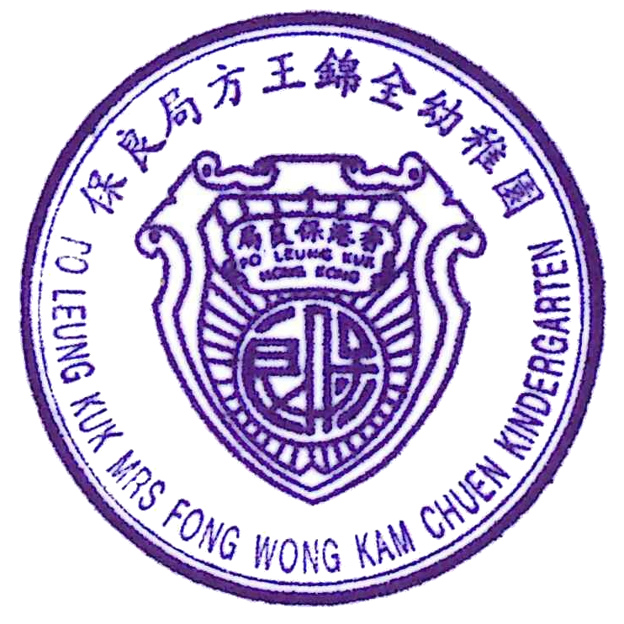
本園2023/2024年度上學期之學習參考資料、簿冊文具、圖工材料、茶點及其他用品各項如下，家長可自由選購或委託本園辦理，倘 貴家長委託本園代辦者，請於2023年6月9日或以前簽覆回條原張交回，本園將於2023年6月30日以銀行自動轉賬方式收取代辦費用，家長亦可以支票或現金方式繳交有關之款項。

保良局方王錦全幼稚園
2023年6月2日
類別 | 名 稱 |  |  | 出 版 社 | 冊 次 | 幼 兒 班 |  |  |  | 需要購買 | 不需要購買
 |  |  |  |  |  | 名 稱 |  | 數量 | 售 價 | 請於適當空格內加✓
Ａ 學習參考資料 | 樂在培生學習系列 |  |  | 聯合培進教育出版社 | 上學期 | 《上學真好玩》 |  | 1 | 60.80
 |  |  |  |  |  | 《這是我！》 |  | 1 | 60.80
 |  |  |  |  |  | 《冬天你會做甚麼？》 |  | 1 | 60.80
Ａ 學習參考資料 | 來說普通話  (2008第三版) |  |  | 教育出版社 | 上冊 | 《來說普通話 幼上》 |  | 1 | 67.20
Ａ 學習參考資料 | Wonder Tales |  |  | 教育出版社 |  | 1,2,3, Exercise! |  | 1 | 56.10
Ａ 學習參考資料 |  |  |  | 教育出版社 |  | My Toys |  | 1 | 56.10
Ａ 學習參考資料 | New Pre-School Longman Elect Talking Pupil’s Book |  |  | 培生教育出版社 | 1 | New Pre-School Longman Elect Talking Pupil’s Book |  | 1 | 74.40
Ａ 學習參考資料 | New Pre-School Longman Elect Talking Act Book |  |  | 培生教育出版社 | 1 | New Pre-School Longman Elect Talking Act Book |  | 1 | 64.00
Ａ 學習參考資料 | 活動遊戲冊 |  |  | 聯合培進教育出版社 | 上學期 | 《活動遊戲冊(幼兒班上學期)》 |  | 1 | 70.40
Ａ 學習參考資料 | 假期樂活動冊 |  |  | 聯合培進教育出版社 |  | 《小鹿丁丁送禮物(幼兒班)》 |  | 1 | 28.00
Ａ 學習參考資料 |  |  |  | 聯合培進教育出版社 |  | 《小貓吉吉大掃除(幼兒班)》 |  | 1 | 28.00
Ａ 學習參考資料 |  |  |  |  | 小 計 |  |  |  | 626.60
Ｂ 圖工材料 | 紙類 |  |  | 美勞用紙 | B.1 |  |  |  | 50.70
Ｂ 圖工材料 | 顏色 |  |  | 圖工顏色類 | B.2 |  |  |  | 50.70
Ｂ 圖工材料 | 用品 |  |  | 美勞用品類 | B.3 |  |  |  | 50.70
Ｂ 圖工材料 | 其他 |  |  | 特別圖工材料 | B.4 |  |  |  | 89.40
Ｂ 圖工材料 |  |  |  |  | 小 計 |  |  |  | 241.50
Ｃ 簿冊及文具 | 項 目 |  |  |  |  | 名 稱 | 數量
Ｃ 簿冊及文具 | 設計活動補充資料 |  |  |  | C.12 | 兒歌書 | 1 |  | 15.00
Ｃ 簿冊及文具 |  |  |  |  | C.12 | Rhymes | 1 |  | 15.00
Ｃ 簿冊及文具 |  |  |  |  | C.12 | Oral | 1 |  | 15.00
Ｃ 簿冊及文具 |  |  |  |  | C.12 | 小肌肉遊戲冊 | 1 |  | 33.00
Ｃ 簿冊及文具 |  |  |  |  | C.12 | 專題研習(1) | 1 |  | 17.70
Ｃ 簿冊及文具 |  |  |  |  | C.12 | 專題研習(2) | 1 |  | 17.70
Ｃ 簿冊及文具 |  |  |  |  | C.12 | 線條遊戲冊 | 1 |  | 20.00
Ｃ 簿冊及文具 |  |  |  |  | 小 計 |  |  |  | 133.40
Ｄ 其他用品 | 學生名牌 |  |  |  | D.1 | 1 |  |  | 33.30
Ｄ 其他用品 | 學生姓名膠印 |  |  |  | D.2 | 2 |  |  | 27.60
Ｄ 其他用品 | 檔案夾 |  |  |  | D.3 | 1 |  |  | 36.20
Ｄ 其他用品 |  |  |  |  | 小 計 |  |  |  | 97.10
Ｅ 茶點費 | 茶點費 |  |  |  | E.1 |  |  |  | 345.00
Ｅ 茶點費 |  |  |  |  | 小 計 |  |  |  | 345.00
總計 |  |  |  |  | 總 計 |  |  |  | 1443.60
敬覆者： 貴園20223/2024年度上學期之學習參考資料、簿冊文具、圖工材料、茶點及其他用品等之收費經已獲悉，現本人願意委託 貴園代辦。敬希察照為荷。
請選擇以下付款方式：
□ 銀行自動轉賬 □ 現金 □ 支票
*請於合適□內加上號
此覆
保良局方王錦全幼稚園
 |  |  |  |  | 家長或授權人簽署：
 | 班 | 學生 |  |  | 日期： | 2023年 月 日
2nd June 2023
Po Leung Kuk Mrs Fong Wong Kam Chuen Kindergarten
School Term 2022-2023
Books and Miscellaneous Fees for 1st School Term of 2023-2024(K1)
Dear Parents,
We will order and supply the books for the students. Books and miscellaneous fees (learning materials, stationaries, art materials, snack and other items) are shown as below. It is optional for parents to choose on placing order for all or part of the items below. Please fill in this form and return it to the school on or before 9th June 2023. Such payment shall be made through autopay on 30th June 2023. Parents may choose to pay the fee by cheque or cash.

Po Leung Kuk Mrs Fong Wong Kam Chuen Kindergarten
Category | Items |  |  | Publisher | Book | K.1 |  |  | ✓purchase | ✓not purchase
 |  |  |  |  |  | Items | Quantity | Price | Please ✓the appropriate box
A.  Textbook | 樂在培生學習系列 |  |  | United Prime Educational Publishing | 1st Term | 《上學真好玩》 | 1 | 60.80
 |  |  |  |  |  | 《這是我！》 | 1 | 60.80
 |  |  |  |  |  | 《冬天你會做甚麼？》 | 1 | 60.80
A.  Textbook | 來說普通話  (2008第三版) |  |  | Educational Publishing House | 1st Term | 《來說普通話 幼上》 | 1 | 67.20
A.  Textbook | Wonder Tales |  |  | Educational Publishing House |  | 1,2,3, Exercise! | 1 | 56.10
A.  Textbook |  |  |  | Educational Publishing House |  | My Toys | 1 | 56.10
A.  Textbook | New Pre-School Longman Elect Talking Pupil’s Book |  |  | Pearson | 1 | New Pre-School Longman Elect Talking Pupil’s Book | 1 | 74.40
A.  Textbook | New Pre-School Longman Elect Talking Act Book |  |  | Pearson | 1 | New Pre-School Longman Elect Talking Act Book | 1 | 64.00
A.  Textbook | Activity workbook |  |  | United Prime Educational Publishing | 1st Term | Activity workbook | 1 | 70.40
A.  Textbook | Holiday Assignment |  |  | United Prime Educational Publishing |  | 《小鹿丁丁送禮物(幼兒班)》 | 1 | 28.00
A.  Textbook |  |  |  | United Prime Educational Publishing |  | 《小貓吉吉大掃除(幼兒班)》 | 1 | 28.00
A.  Textbook |  |  |  |  | Sub total |  |  | 626.60
B.  Art materials | Papers |  |  | Art paper | B.1 |  |  | 50.70
B.  Art materials | Colors |  |  | Colors | B.2 |  |  | 50.70
B.  Art materials | Supplies |  |  | Art supplies | B.3 |  |  | 50.70
B.  Art materials | Others |  |  | Other materials | B.4 |  |  | 89.40
B.  Art materials |  |  |  |  | Sub total |  |  | 241.50
C.  Books & stationaries | Items |  |  |  |  | Items | Quantity
C.  Books & stationaries | Supplementary materials for project activities |  |  |  | C.12 | Chinese Oral Book | 1 | 15.00
C.  Books & stationaries |  |  |  |  | C.12 | Rhymes | 1 | 15.00
C.  Books & stationaries |  |  |  |  | C.12 | Oral | 1 | 15.00
C.  Books & stationaries |  |  |  |  | C.12 | Fine Motor Skill Activities | 1 | 32.00
C.  Books & stationaries |  |  |  |  | C.12 | Project-based Learning(1) | 1 | 17.70
C.  Books & stationaries |  |  |  |  | C.12 | Project-based Learning(2) | 1 | 17.70
C.  Books & stationaries |  |  |  |  | C.12 | Line Game Book | 1 | 20.00
C.  Books & stationaries |  |  |  |  | Sub total |  |  | 133.40
D.  Other items | Student name tag |  |  |  | D.1 | 1 |  | 33.30
D.  Other items | Student name stamp |  |  |  | D.2 | 2 |  | 27.60
D.  Other items | Box file |  |  |  | D.3 | 1 |  | 36.20
D.  Other items |  |  |  |  | Sub total |  |  | 97.10
E.  Snack | Snack fee |  |  |  | E.1 |  |  | 345.00
E.  Snack |  |  |  |  | Sub total |  |  | 345.00
Total |  |  |  |  | Total |  |  | 1443.60
To Po Leung Kuk Mrs Fong Wong Kam Chuen Kindergarten: This is to acknowledge that I received the circular about the Books and Miscellaneous Fees for 1st School Term of 2023-2024. I will give the authorization to school for purchasing these items on behalf of the agency.
Payment method:
□ Autopay □ Cash □ Cheque
*Please  the appropriate box.
Student’s name: Parent’s signature:
Class: Date:

